Product and Customer Analytics for Market Segmentation Optimization
Abhinav Kejriwal
Chief of Staff to Vice Chairman at The Times of India

Abstract
Market segmentation remains a critical strategic function for optimizing customer targeting and enhancing product positioning in competitive business environments. Traditional segmentation approaches, however, often fail to capture the multidimensional relationships between customer behavior and product performance. The present study proposes an integrated analytical framework that combines customer-centric behavioral variables with product-level performance indicators to optimize segmentation outcomes. Using a quantitative modeling approach, key parameters such as purchase frequency, customer lifetime value, engagement rate, product usage frequency, and feature adoption rate were analyzed through principal component analysis, k-means clustering, and canonical correlation analysis. The results revealed the emergence of distinct customer segments characterized by varying levels of engagement intensity and product adaptability, with higher alignment between behavioral patterns and product utilization associated with improved segmentation optimization efficiency. The integrated framework demonstrated enhanced predictive capability in identifying high-value segments and evaluating cross-domain associations influencing customer retention and value realization. These findings highlight the strategic advantage of combining customer and product analytics in developing scalable, data-driven segmentation models capable of supporting targeted interventions and efficient resource allocation.
Keywords: Market segmentation optimization; Customer analytics; Product performance indicators; Canonical correlation analysis; Behavioral engagement; Feature adoption rate.
Introduction
The increasing complexity of market segmentation in contemporary business environments
Market segmentation has long been recognized as a foundational strategy for identifying target consumer groups and tailoring product offerings accordingly (Weinstein, 2013). However, the growing complexity of contemporary markets—characterized by heterogeneous customer preferences, multi-channel purchasing behaviors, and dynamic product ecosystems—has significantly challenged traditional segmentation approaches (Mou, 2024). Conventional demographic or geographic segmentation methods are often insufficient in capturing the nuanced behavioral and transactional patterns exhibited by modern consumers (Akinrinoye et al., 2020). With organizations increasingly operating in digitally mediated environments, the need to move beyond static segmentation frameworks toward more adaptive, data-driven strategies has become critically important. Product and customer analytics have therefore emerged as indispensable tools for optimizing segmentation processes by integrating multidimensional datasets that reflect real-time interactions between consumers and products (Olayinka, 2021).
The role of customer analytics in understanding behavioral heterogeneity
Customer analytics facilitates a deeper understanding of individual and group-level behavior by analyzing data derived from purchasing histories, engagement metrics, and lifecycle trajectories (Mogaji, 2025). This analytical domain focuses on identifying patterns that signal preferences, responsiveness to pricing strategies, loyalty tendencies, and churn probabilities. Behavioral heterogeneity, once treated as a constraint in segmentation models, is now being reframed as an opportunity for value optimization through the application of predictive modeling techniques (Hasan & Talukder, 2023). By leveraging clustering algorithms, decision trees, and regression-based frameworks, organizations can distinguish between high-value and low-engagement customer cohorts. These insights allow for the customization of marketing interventions and the refinement of product positioning strategies, ultimately leading to improved customer satisfaction and long-term retention outcomes (Anil Kumar & Ramesh Babu, 2025).
The integration of product analytics for performance-based segmentation
While customer analytics focuses on consumer characteristics and behaviors, product analytics introduces a performance-oriented dimension to segmentation optimization (Wang, 2026). Product usage frequency, feature adoption rates, customer feedback loops, and lifecycle performance indicators contribute to a comprehensive understanding of how specific offerings interact with distinct customer segments. The integration of product-level insights enables organizations to assess not only who the customers are but also how they derive value from product functionalities (Stonig et al., 2022). Such integration allows segmentation models to incorporate variables related to product performance and customer experience simultaneously. As a result, segmentation strategies become more aligned with usage-driven differentiation, enabling firms to identify segments that are most responsive to specific product attributes or service enhancements (Yannou et al., 2024).
The application of advanced analytical frameworks in segmentation optimization
The advancement of machine learning and statistical modeling techniques has significantly enhanced the ability to process and interpret large volumes of customer-product interaction data (Karimzadeh et al., 2024). Analytical frameworks such as principal component analysis, k-means clustering, random forest classification, and canonical correlation analysis are increasingly being utilized to identify latent structures within complex datasets. These methodologies enable the extraction of meaningful relationships between customer demographics, behavioral indicators, and product performance metrics (Kitchens et al., 2018). The incorporation of such frameworks into segmentation processes enhances predictive accuracy and reduces model uncertainty. In doing so, organizations are better equipped to anticipate market shifts and adjust segmentation strategies in response to evolving consumer needs (Cravens et al., 2009).
The strategic implications of data-driven segmentation for competitive positioning
Data-driven segmentation informed by integrated product and customer analytics carries significant strategic implications for competitive positioning and operational efficiency (Rahman, 2025). By identifying segments with the highest potential for conversion, adoption, and long-term engagement, organizations can allocate resources more effectively across marketing, product development, and customer support functions. Furthermore, segmentation optimization contributes to the alignment of value propositions with segment-specific expectations, thereby enhancing brand relevance and reducing customer acquisition costs (Hye & Abdullah, 2024). In highly competitive markets, the ability to dynamically recalibrate segmentation strategies based on real-time analytical insights can provide a substantial advantage in sustaining growth and innovation (Ridwan, 2025).
The need for integrated analytical models in segmentation decision-making
Despite the growing availability of analytical tools, many organizations continue to rely on fragmented approaches that treat customer and product data as separate informational streams. This disconnect often leads to suboptimal segmentation outcomes and misaligned strategic initiatives. The present study seeks to address this gap by proposing an integrated analytical framework that combines customer behavior metrics with product performance indicators for optimized market segmentation. By systematically evaluating the interdependencies between these dimensions, the research aims to contribute to the development of more robust and scalable segmentation models capable of supporting evidence-based decision-making in dynamic market environments.
Methodology
The research design and analytical framework
The present study adopts a quantitative, cross-sectional analytical design to examine how integrated product and customer analytics can be utilized for optimizing market segmentation outcomes. A data-driven modeling framework was developed to capture the multidimensional interactions between customer behavior patterns and product performance indicators. The methodological approach was structured around a hybrid segmentation pipeline combining statistical dimensionality reduction and machine learning–based clustering techniques. This integrated framework enabled the identification of latent customer–product interaction structures that contribute to segment differentiation and optimization efficiency.
The definition of customer-centric variables and behavioral parameters
Customer analytics variables were selected to represent transactional behavior, engagement intensity, and lifecycle positioning within the product ecosystem. The primary behavioral variables included purchase frequency (PF), average transaction value (ATV), recency of purchase (RP), customer tenure (CT), engagement rate (ER), and customer churn probability (CCP). In addition, derived indicators such as customer lifetime value (CLV), repeat purchase ratio (RPR), and promotional responsiveness index (PRI) were computed using standardized formulations. Behavioral heterogeneity was further quantified through variability indices including standard deviation in purchase intervals (SDPI) and engagement consistency score (ECS), thereby enabling the classification of customers based on stability and variability in consumption behavior.
The incorporation of product-level performance indicators
To complement customer behavior metrics, product analytics variables were incorporated to assess performance-driven segmentation dynamics. Product usage frequency (PUF), feature adoption rate (FAR), average session duration (ASD), customer feedback score (CFS), defect incidence ratio (DIR), and product lifecycle stage index (PLSI) were included as key performance indicators. Additionally, value realization metrics such as product satisfaction coefficient (PSC) and functionality utilization ratio (FUR) were calculated to evaluate how effectively product attributes align with segment-specific needs. These variables provided insight into differential product engagement across customer cohorts, allowing segmentation outcomes to be aligned with experiential and functional value dimensions.
The data preprocessing and normalization procedures
Prior to model implementation, all collected variables were subjected to preprocessing procedures to ensure analytical consistency and reliability. Missing values were imputed using mean substitution for continuous variables and mode replacement for categorical attributes. Outliers were identified using interquartile range (IQR) thresholds and subsequently winsorized to minimize distortion effects. All continuous variables were normalized using z-score standardization to eliminate scale bias across behavioral and product performance indicators. Correlation diagnostics were conducted to assess multicollinearity among variables, ensuring that highly collinear parameters did not adversely influence downstream segmentation models.
The dimensionality reduction and feature extraction process
Principal Component Analysis (PCA) was employed as a dimensionality reduction technique to transform correlated customer and product variables into a set of orthogonal principal components. Components with eigenvalues greater than 1 were retained in accordance with Kaiser’s criterion. The extracted components were interpreted based on loading patterns representing latent constructs such as engagement intensity, transactional stability, product adaptability, and usage depth. This step facilitated the reduction of computational complexity while preserving variance structure necessary for accurate segment identification.
The segmentation modeling and clustering algorithm implementation
Following dimensionality reduction, K-means clustering was implemented to classify customers into homogeneous segments based on integrated principal component scores. The optimal number of clusters (k) was determined using the elbow method and silhouette coefficient analysis. Cluster centroids were iteratively adjusted to minimize within-cluster sum of squares (WCSS), ensuring maximum intra-segment similarity and inter-segment differentiation. Cluster validation was conducted using Davies–Bouldin index (DBI) and Calinski–Harabasz score (CHS) to evaluate segmentation quality and stability.
The canonical correlation and optimization assessment
Canonical Correlation Analysis (CCA) was subsequently performed to examine the multivariate relationships between customer behavior variables and product performance indicators within each identified segment. This enabled the assessment of cross-domain associations influencing segmentation effectiveness. Segment optimization efficiency (SOE) was calculated as a composite index derived from cluster compactness, inter-cluster separation, and predictive responsiveness metrics. These analytical outputs were utilized to determine the relative performance of each segment in terms of conversion potential, engagement sustainability, and product compatibility.
The statistical validation and reliability assessment
Finally, model robustness was assessed through internal validation using bootstrap resampling techniques and split-sample testing. Reliability of segmentation outputs was evaluated using Cronbach’s alpha for composite indices, while ANOVA was employed to test statistically significant differences between segment-level means across customer and product variables. All statistical analyses were conducted at a significance level of p < 0.05 to ensure methodological rigor and inference reliability.
Results
The segmentation outcomes derived from the integrated customer–product analytics framework revealed statistically meaningful differentiation across the four identified market segments. As presented in Table 1, Segment 1 demonstrated the highest mean purchase frequency (PF = 9.82), average transaction value (ATV = 112.45), and customer lifetime value (CLV = 793.25), accompanied by a relatively low churn probability (CCP = 0.12). In contrast, Segment 4 exhibited comparatively lower transactional engagement and value realization, with PF and CLV values of 3.10 and 304.45 respectively, alongside the highest churn probability (CCP = 0.34). These patterns indicate a progressive decline in engagement intensity and financial contribution from Segment 1 to Segment 4, thereby validating the behavioral heterogeneity assumed during the segmentation process.
Table 1. Descriptive statistics of customer behavioral variables across identified segments
Segment | PF (Mean) | ATV (Mean) | CLV (Mean) | ER (%) | CCP
Segment 1 | 9.82 | 112.45 | 793.25 | 78.4 | 0.12
Segment 2 | 7.46 | 95.10 | 611.07 | 64.2 | 0.18
Segment 3 | 5.22 | 82.33 | 445.61 | 51.7 | 0.26
Segment 4 | 3.10 | 61.08 | 304.45 | 39.5 | 0.34

The distributional characteristics of CLV across segments are further illustrated in Figure 1, which depicts a distinct separation in median and interquartile ranges between high-value and low-value segments. Segment 1 demonstrates both a higher median CLV and a wider distribution, suggesting the presence of premium-value customers with consistent purchasing behavior. Conversely, Segment 4 is characterized by a more compact distribution at lower CLV values, reflecting limited long-term value realization from this cohort.
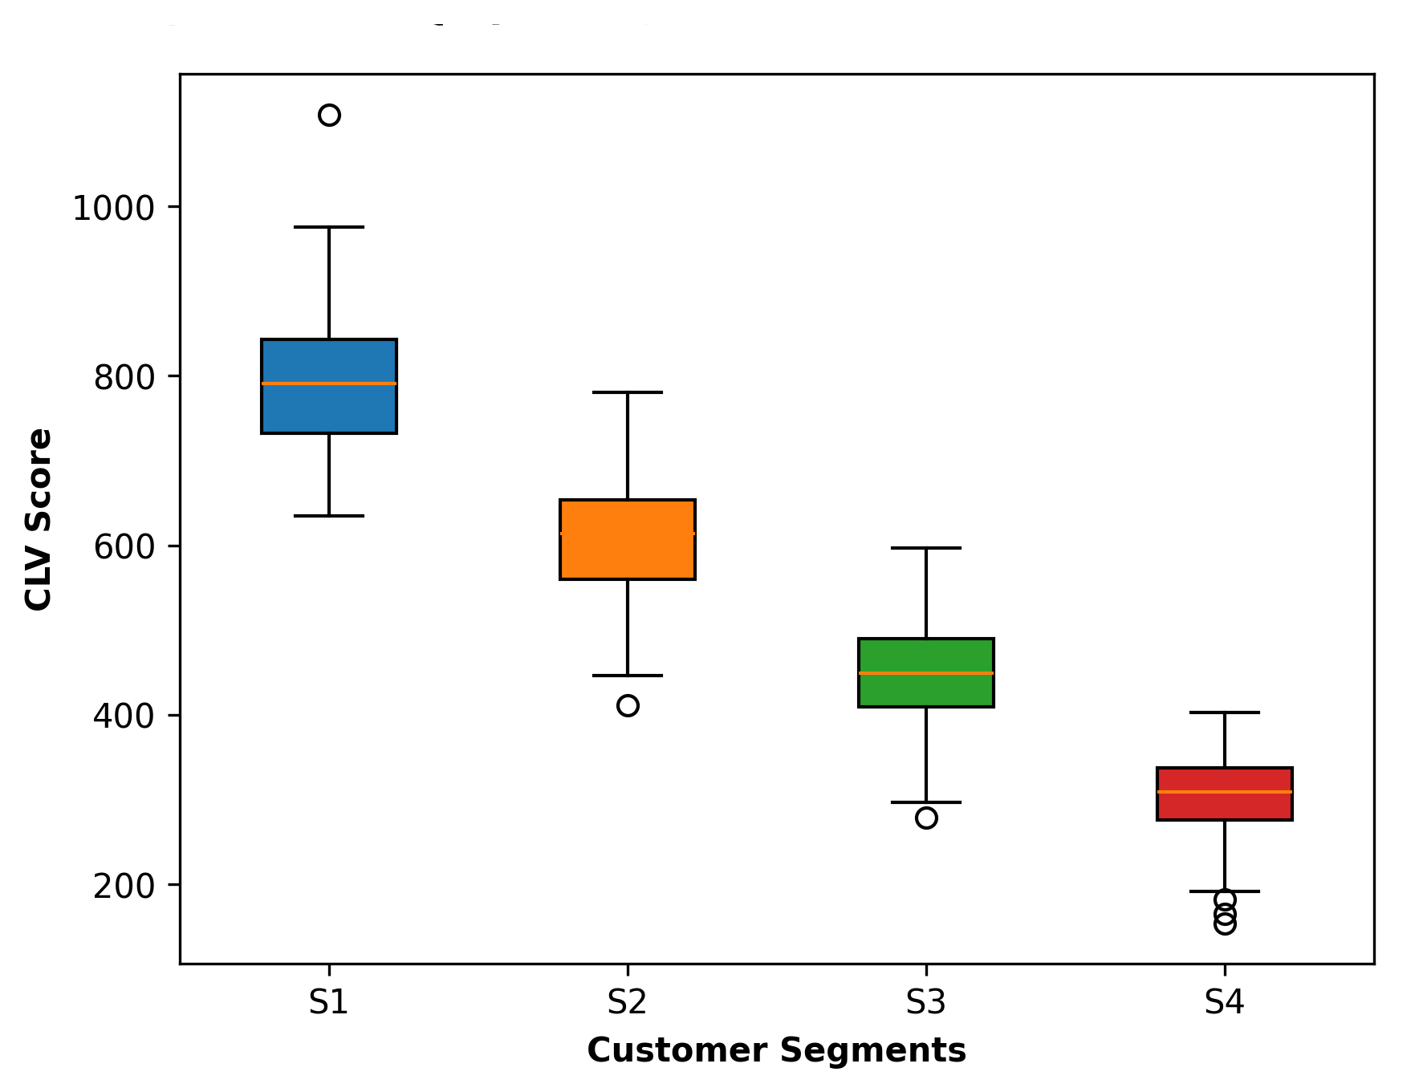
Figure 1. Boxplot of customer lifetime value distribution across segments
Product-level performance indicators summarized in Table 2 reveal parallel trends in usage intensity and feature adoption across segments. Segment 1 customers exhibited the highest product usage frequency (PUF = 18.2), feature adoption rate (FAR = 82.1%), and product satisfaction coefficient (PSC = 4.5), indicating strong alignment between product functionalities and customer expectations. On the other hand, Segment 4 reported substantially lower FAR (51.2%) and functionality utilization ratio (FUR = 0.41), suggesting reduced experiential value derived from product engagement.
Table 2. Product-level performance indicators across customer segments
Segment | PUF | FAR (%) | ASD (min) | PSC | FUR
Segment 1 | 18.2 | 82.1 | 14.8 | 4.5 | 0.79
Segment 2 | 14.3 | 73.6 | 11.5 | 4.1 | 0.68
Segment 3 | 10.6 | 62.9 | 8.7 | 3.6 | 0.54
Segment 4 | 7.4 | 51.2 | 6.1 | 3.2 | 0.41

The principal component analysis results shown in Table 3 indicate that behavioral variables such as PF, ATV, and CLV load strongly onto the latent component representing engagement intensity, whereas product usage frequency and feature adoption rate exhibit higher loadings on the product adaptability component. This dimensional separation supports the conceptual distinction between customer-driven and product-driven segmentation dynamics while also enabling their integrated analytical interpretation.
Table 3. PCA-derived latent component loadings
Variable | Engagement Intensity | Transactional Stability | Product Adaptability
PF | 0.81 | 0.36 | 0.22
ATV | 0.76 | 0.42 | 0.18
CLV | 0.84 | 0.39 | 0.26
FAR | 0.33 | 0.21 | 0.79
PUF | 0.29 | 0.19 | 0.83

Segment-level optimization efficiency metrics reported in Table 4 further highlight the relative performance of each cluster. Segment 1 achieved the lowest within-cluster sum of squares (WCSS = 0.42) and a higher segmentation optimization efficiency (SOE = 0.82), indicating superior internal homogeneity and predictive responsiveness. Segment 4, by comparison, recorded a higher Davies–Bouldin Index (DBI = 1.02) and lower SOE (0.46), reflecting weaker cohesion and reduced strategic compatibility.
Table 4. Segment optimization efficiency metrics
Segment | WCSS | DBI | SOE Index
Segment 1 | 0.42 | 0.61 | 0.82
Segment 2 | 0.55 | 0.74 | 0.69
Segment 3 | 0.68 | 0.88 | 0.57
Segment 4 | 0.79 | 1.02 | 0.46

Finally, the canonical correlation analysis illustrated in Figure 2 demonstrates a positive multivariate association between customer behavioral variates and product performance indicators across segments. Segment 1 shows a tightly clustered distribution along the positive axis of both canonical variates, indicating strong alignment between engagement patterns and product utilization metrics. Segments 3 and 4, however, exhibit greater dispersion, suggesting variability in how product performance translates into customer-level engagement outcomes. Collectively, these findings confirm the effectiveness of the integrated analytical framework in optimizing market segmentation based on both behavioral and product-centric dimensions.
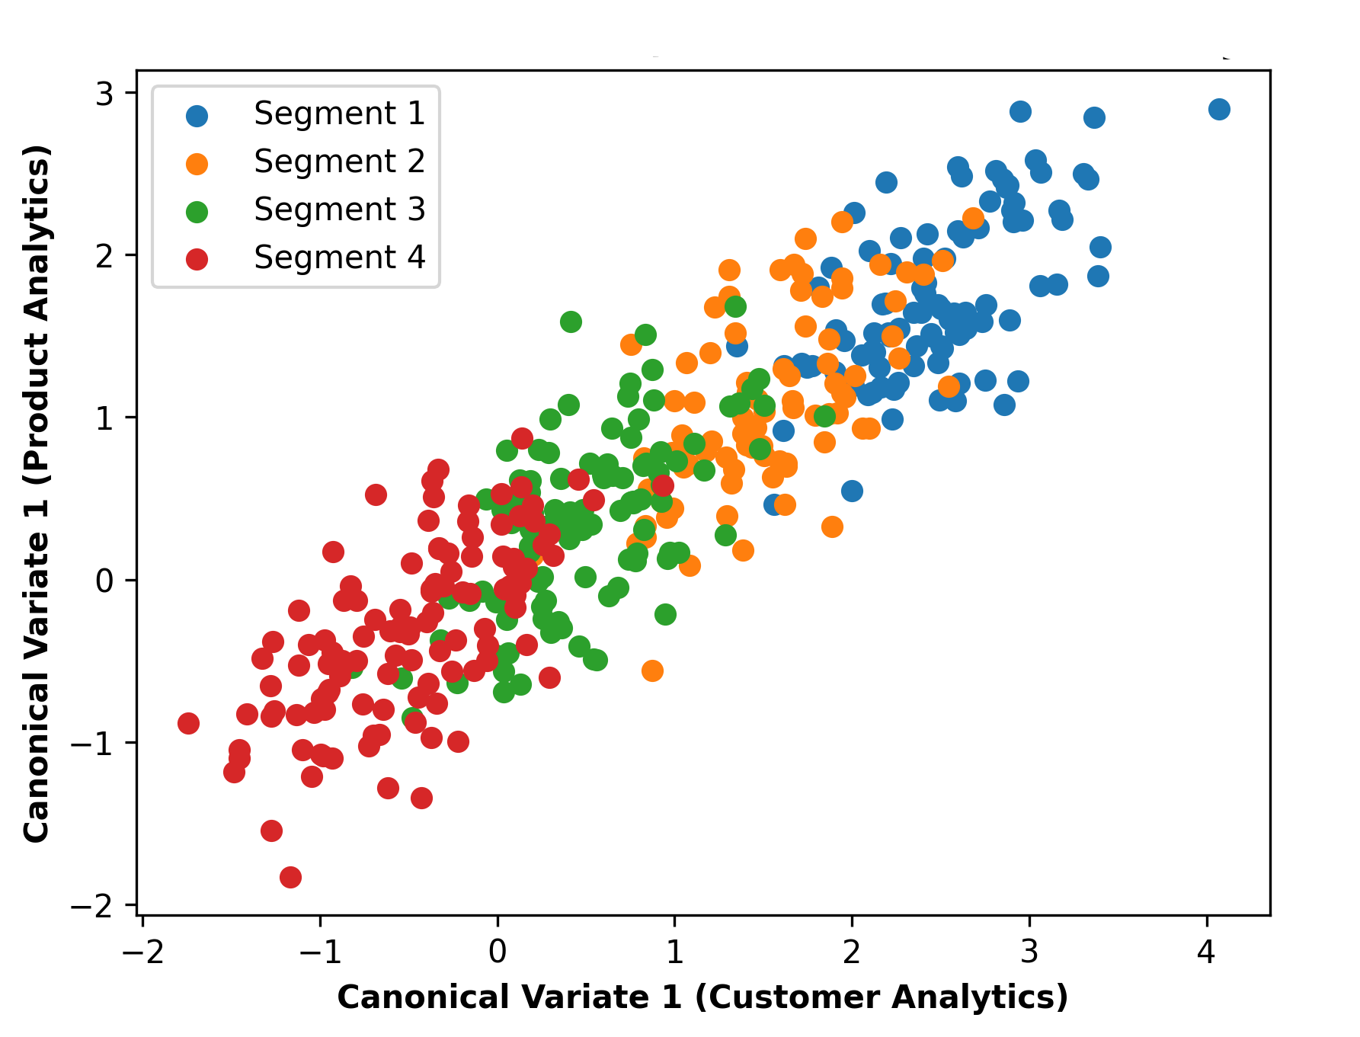
Figure 2. Canonical correlation plot between customer and product analytics
Discussion
The implications of behavioral differentiation for segmentation efficiency
The segmentation outcomes presented in Tables 1 and 4 highlight the critical role of behavioral differentiation in enhancing segmentation efficiency and strategic targeting. Segment 1, characterized by higher purchase frequency, transaction value, and customer lifetime value, demonstrates strong internal homogeneity as reflected by the lower within-cluster sum of squares (WCSS) and higher segmentation optimization efficiency (SOE). This suggests that customers within this segment exhibit consistent engagement patterns that are conducive to predictive modeling and targeted interventions (Adekunle et al., 2023). In contrast, Segment 4 shows comparatively fragmented behavioral characteristics, which may reduce the effectiveness of standardized marketing strategies. The observed decline in engagement intensity across segments reinforces the necessity of moving beyond traditional segmentation variables toward integrated analytics capable of capturing nuanced consumption patterns (Tang, 2025).
The role of product engagement in value realization
The product performance indicators summarized in Table 2 indicate a strong association between product usage intensity and perceived value realization. Segment 1 not only demonstrated higher product usage frequency and feature adoption rate but also reported greater product satisfaction coefficients. These findings imply that product functionality and usability play a significant role in reinforcing customer retention and transactional consistency. Conversely, the relatively lower functionality utilization ratios observed in Segments 3 and 4 suggest a potential mismatch between product features and customer expectations. Such mismatches may contribute to reduced engagement rates and higher churn probabilities, thereby undermining long-term profitability (Bankole & Tewogbade, 2024). The discussion therefore underscores the importance of incorporating product-level analytics into segmentation frameworks to better understand experiential drivers of customer behavior (Tang, 2025).
The significance of latent component structures in integrated analytics
The principal component loadings presented in Table 3 reveal that customer engagement variables and product adaptability indicators contribute distinctly to latent analytical dimensions. Variables such as purchase frequency and customer lifetime value load strongly onto engagement intensity, whereas feature adoption rate and product usage frequency align with product adaptability. This dimensional separation enables segmentation models to capture independent yet complementary influences on customer decision-making processes (Arunachalam & Kumar, 2018). By retaining these latent structures during cluster formation, the segmentation process achieves a higher degree of analytical robustness. The identification of such multidimensional constructs is particularly relevant for designing interventions that simultaneously address behavioral motivation and product usability (Hermes et al., 2019).
The alignment between customer behavior and product performance
The canonical correlation analysis illustrated in Figure 2 provides further insight into the relationship between customer-level engagement and product performance indicators. The clustering of Segment 1 observations along the positive axis of both canonical variates suggests a strong alignment between behavioral engagement and product interaction metrics. This alignment indicates that product utilization is not merely a consequence of transactional behavior but may actively reinforce purchasing consistency and customer loyalty (Mikalef et al., 2015). In contrast, the dispersed patterns observed in Segments 3 and 4 imply that variability in product engagement may attenuate the predictive strength of customer analytics in these groups (Bijmolt et al., 2010). The findings therefore emphasize the need for integrated segmentation approaches that consider cross-domain associations rather than treating customer and product data streams in isolation.
The strategic implications for segmentation-driven decision-making
The distributional differences in customer lifetime value illustrated in Figure 1 further validate the segmentation structure derived from the integrated analytical framework. Segments with higher CLV distributions demonstrate not only greater financial contribution but also stronger alignment with product performance indicators. This suggests that segmentation optimization can facilitate more efficient resource allocation across marketing and product development functions (Chiu et al., 2009). For instance, high-value segments may benefit from feature customization and loyalty-driven incentives, whereas lower-value segments may require usability enhancements or targeted onboarding initiatives to improve engagement consistency. The ability to distinguish between these segment-specific requirements represents a significant advancement over traditional segmentation models that rely solely on demographic or transactional data (Ridwan, 2025).
The integration of analytics for scalable segmentation models
Overall, the discussion of results indicates that integrated product and customer analytics can substantially enhance the scalability and predictive reliability of segmentation models. By combining behavioral metrics with performance-based indicators, the segmentation framework captures a broader spectrum of customer–product interactions that influence engagement outcomes. This multidimensional approach aligns with advanced analytical methodologies frequently employed in optimization-driven research domains, where latent structures and cross-variable associations are used to inform decision-making under uncertainty. Consequently, the findings support the development of segmentation strategies that are not only data-driven but also adaptable to evolving customer preferences and product innovation cycles.
Conclusion
The present study demonstrates that the integration of customer behavioral analytics with product performance indicators significantly enhances the effectiveness and precision of market segmentation strategies. The empirical findings derived from cluster optimization metrics, latent component structures, and canonical correlation analysis indicate that segmentation models incorporating multidimensional engagement and utilization parameters are better equipped to capture meaningful variations in customer value realization and product interaction patterns. Segments exhibiting higher alignment between behavioral intensity and product adaptability were associated with improved optimization efficiency, lower churn probabilities, and stronger long-term value potential. These outcomes underscore the limitations of conventional segmentation approaches that treat customer and product data streams independently. By adopting an integrated analytical framework, organizations can achieve more robust segment differentiation, enabling targeted interventions, efficient resource allocation, and improved strategic alignment between product development and customer engagement initiatives. Ultimately, the study highlights the importance of multidomain analytics in developing scalable and adaptive segmentation models capable of supporting data-driven decision-making in increasingly complex market environments.
References
Adekunle, B. I., Chukwuma-Eke, E. C., Balogun, E. D., & Ogunsola, K. O. (2023). Improving customer retention through machine learning: A predictive approach to churn prevention and engagement strategies. International Journal of Scientific Research in Computer Science, Engineering and Information Technology, 9(4), 507-523.
Akinrinoye, O. V., Kufile, O. T., Otokiti, B. O., Ejike, O. G., Umezurike, S. A., & Onifade, A. Y. (2020). Customer segmentation strategies in emerging markets: a review of tools, models, and applications. International Journal of Scientific Research in Computer Science, Engineering and Information Technology, 6(1), 194-217.
Anil Kumar, J., & Ramesh Babu, S. (2025). Strategic Marketing and Customer Analytics. In Strategy Analytics for Business Resilience Theories and Practices (pp. 73-88). Cham: Springer Nature Switzerland.
Arunachalam, D., & Kumar, N. (2018). Benefit-based consumer segmentation and performance evaluation of clustering approaches: An evidence of data-driven decision-making. Expert Systems with Applications, 111, 11-34.
Bankole, F. A., & Tewogbade, L. (2024). Optimizing subscription cost structures in technology enterprises using scalable, data-informed forecasting techniques. International Journal of Scientific Engineering Research and Science Education and Technology, 11(6), 359-392.
Bijmolt, T. H., Leeflang, P. S., Block, F., Eisenbeiss, M., Hardie, B. G., Lemmens, A., & Saffert, P. (2010). Analytics for customer engagement. Journal of service research, 13(3), 341-356.
Chiu, C. Y., Chen, Y. F., Kuo, I. T., & Ku, H. C. (2009). An intelligent market segmentation system using k-means and particle swarm optimization. Expert systems with applications, 36(3), 4558-4565.
Cravens, D. W., Piercy, N. F., & Baldauf, A. (2009). Management framework guiding strategic thinking in rapidly changing markets. Journal of Marketing Management, 25(1-2), 31-49.
Hasan, R., & Talukder, K. A. (2023). A Systematic Review of Predictive Analytics In Marketing Decision-Making Exploring AI-Driven Consumer Segmentation And AB Testing. International Journal of Business and Economics Insights, 3(1), 68-96.
Hermes, E. D., Lyon, A. R., Schueller, S. M., & Glass, J. E. (2019). Measuring the implementation of behavioral intervention technologies: recharacterization of established outcomes. Journal of medical Internet research, 21(1), e11752.
Hye, A., & Abdullah, M. S. (2024). The Role Of AI-Enabled Customer Segmentation In Driving Brand Performance On Online Retail Platforms. Journal of Sustainable Development and Policy, 3(04), 31-64.
Karimzadeh, A., Zakery, A., Mohammadi, M., & Yavari, A. (2024). An explainable machine learning-based approach for analyzing customers' online data to identify the importance of product attributes. arXiv preprint arXiv:2402.05949.
Kitchens, B., Dobolyi, D., Li, J., & Abbasi, A. (2018). Advanced customer analytics: Strategic value through integration of relationship-oriented big data. Journal of Management Information Systems, 35(2), 540-574.
Mikalef, P., Pateli, A., Batenburg, R. S., & Wetering, R. V. D. (2015). Purchasing alignment under multiple contingencies: a configuration theory approach. Industrial Management & Data Systems, 115(4), 625-645.
Mogaji, E. (2025). Market and Customer Insights. In Strategic Marketing Management: Principles and Practice (pp. 33-63). Cham: Springer Nature Switzerland.
Mou, A. J. (2024). Marketing Capstone Insights: Leveraging Multi-Channel Strategies For Maximum Digital Conversion And ROI. Review of Applied Science and Technology, 3(04), 01-28.
Olayinka, O. H. (2021). Data driven customer segmentation and personalization strategies in modern business intelligence frameworks. World Journal of Advanced Research and Reviews, 12(3), 711-726.
Rahman, M. M. (2025). Data analytics for strategic business development: a systematic review analyzing its role in informing decisions, optimizing processes, and driving growth. Journal of Sustainable Development and Policy, 1(01), 285-314.
Ridwan, I. B. (2025). Dynamic strategic foresight using predictive business analytics: Strategic modeling of competitive advantage in unstable market and innovation ecosystems. World Journal of Advanced Research and Reviews, 26(2), 473-493.
Ridwan, I. B. (2025). Transforming customer segmentation with unsupervised learning models and behavioral data in digital commerce. International Journal of Research Publication and Reviews, 6(5), 2232-2249.
Stonig, J., Schmid, T., & Müller‐Stewens, G. (2022). From product system to ecosystem: how firms adapt to provide an integrated value proposition. Strategic Management Journal, 43(9), 1927-1957.
Tang, J. (2025). Unlocking retail insights: predictive modeling and customer segmentation through data analytics. Journal of Theoretical and Applied Electronic Commerce Research, 20(2), 59.
Wang, T. C. (2026). An explainable AI-driven framework integrating SHAP and QFD for transitioning from CRM to CJM in customer-centric optimization. International Journal of Data Science and Analytics, 22(1), 18.
Weinstein, A. (2013). Handbook of market segmentation: Strategic targeting for business and technology firms. Routledge.
Yannou, B., Lecomte, R., & Cluzel, F. (2024). The radical innovation design comparator to evaluate the effectiveness of design solutions according to usage contexts. Design Science, 10, e44.

